**Student attendance with face recognition (LBPH or CNN)**

**1. Abstract**

In recent years, university attendance systems have evolved from manual methods to RFID technology. However, these systems still face challenges, such as students forgetting their cards and potential attendance manipulation. Facial recognition technology (FRT) has emerged as a promising solution by using students' faces for attendance, eliminating the need for cards. This article compares two prominent facial recognition algorithms: Convolutional Neural Networks (CNN) and Local Binary Patterns Histogram (LBPH). Based on a literature review, it is found that CNN offers superior accuracy and stability compared to LBPH, especially in environments where external factors like lighting or facial changes could affect performance. The study concludes that CNN is the more effective choice for implementing facial recognition systems in university environments.

**2. Tools and Techniques Used**

* **Convolutional Neural Networks (CNN):** A deep learning model used to analyze and classify facial features by learning complex patterns in facial images. It excels in handling variations in lighting, facial expressions, and angles.
* **Local Binary Patterns Histogram (LBPH**): A simpler, traditional computer vision technique that uses grayscale facial images and computes local binary patterns, creating histograms for facial classification. It is fast but less accurate than CNN.
* **Cameras:** For capturing images or video feeds of students to use in facial recognition.
* **RFID System (as a comparison):** The traditional method where students use cards with RFID tags for attendance marking.

**3. Working of the System**

1. **Image Capture:** Cameras capture the face of the student when they enter the classroom or designated area.
2. **Preprocessing:** The system preprocesses the captured image, adjusting factors like lighting or noise to improve recognition accuracy.
3. **Facial Recognition Algorithm:**
   1. If using CNN, the system analyzes the face by passing the image through several layers that detect various facial features, eventually classifying the face.
   2. If using LBPH, the system converts the image to grayscale, computes the local binary patterns, and compares the histogram generated from the patterns to the stored facial data.
4. **Attendance Marking:** Once the face is recognized, the student's attendance is automatically recorded in the system's database, eliminating the need for manual intervention or RFID cards.

**4. Merits**

* **High Accuracy:** Systems using CNN offer very high accuracy, making it suitable for environments where precision is key.
* **No Need for Physical Cards:** Facial recognition eliminates the need for RFID cards or other physical tokens, making it more convenient for students and reducing the chances of forgotten or lost cards.
* **Prevents Cheating:** Since only the student's face can be used for attendance, it becomes much harder to manipulate or falsify attendance.
* **Non-Intrusive:** Attendance can be marked without requiring students to perform any specific action, like scanning a card.
* **Scalability:** The system can scale for larger institutions with multiple biometric devices.

**5. Demerits**

* **Implementation Cost:** High-quality cameras and the hardware needed to run sophisticated algorithms like CNN may increase the cost of system implementation.
* **Privacy Concerns**: Storing facial data raises privacy concerns, especially regarding the potential misuse of personal biometric data.
* **External Factors:** Although CNN is robust, factors like poor lighting, occlusions (e.g., hats, masks), or drastic changes in appearance (e.g., haircuts) could still affect accuracy to some extent.
* **Processing Time:** While CNN offers high accuracy, it requires more computational power and time compared to LBPH, especially in large-scale implementations.
* **Computationally Intensive:** Algorithms like CNN and SVM require significant computational power and time, especially for large-scale implementations.
* **False Rejections:** Depending on the quality of data and external factors, even robust algorithms like CNN or SVM can falsely reject valid users.

**6.LBPH**

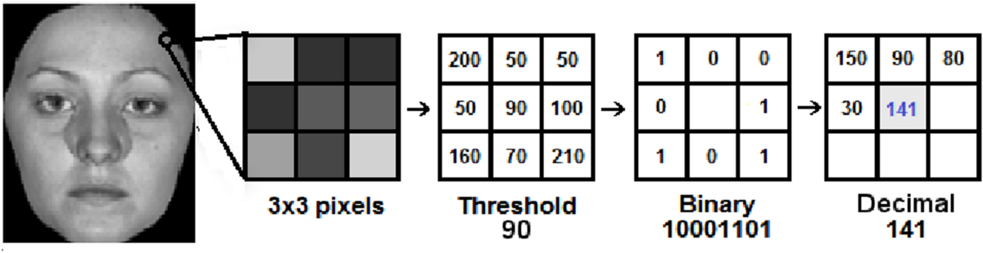

**1.Local Binary Patterns (LBP):**

* The LBP operator transforms an image into a binary format based on the intensity of neighboring pixels.
* For each pixel in the grayscale image, you compare it to its neighboring pixels (usually 8 surrounding pixels).
* If a neighboring pixel has a greater or equal intensity, it is assigned a value of 1; otherwise, it is assigned a value of 0. This forms an 8-bit binary number for each pixel.

**2.Histogram Generation:**

* Once the binary values are assigned, you can compute a histogram of these binary patterns. This histogram represents the frequency of each pattern in the image and serves as a feature descriptor for the face.

**3.Face Recognition:**

* In the recognition phase, the histograms of the input image (query image) and the stored images (database) are compared using a distance metric (like Chi-square or Euclidean distance).
* The image with the closest histogram to the input image is considered the recognized face.

CNN:

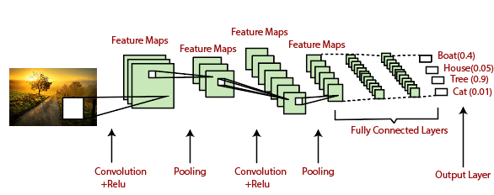

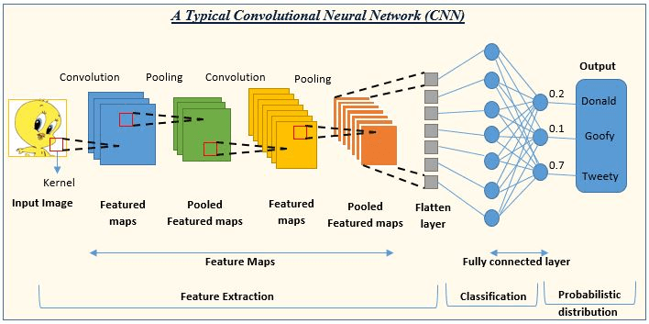

**7.Flow Chart**

No

Yes

Stop

Return to Capture

Take attendance

Found?

LBPH

CNN

Algorithm

Preprocessing

Image Capture

Start